**THE RISE OF E-LEARNING**

The rise of e-learning has been nothing short of transformative, revolutionizing the way people access education and training across the globe. In this exploration, we'll delve into the factors driving the surge in e-learning, its impact on traditional education models, and the opportunities and challenges it presents.   
  
**1. Accessibility and Flexibility:** One of the primary drivers behind the rise of e-learning is its unparalleled accessibility and flexibility. With e-learning platforms and courses available online, learners can access educational materials anytime, anywhere, and at their own pace. This flexibility eliminates geographical barriers and time constraints, allowing individuals to pursue education while balancing work.

**2. Technological Advancements:** Advances in technology, particularly the internet and digital devices, have played a pivotal role in fueling the growth of e-learning. With the proliferation of smartphones, tablets, and laptops, coupled with high-speed internet connectivity, learners now have the tools they need to engage in online learning experiences seamlessly. Additionally, innovations in virtual reality (VR), augmented reality (AR), and artificial intelligence (AI) are enhancing the quality and interactivity of e-learning content.

**3. Cost-Effectiveness:** E-learning offers a cost-effective alternative to traditional classroom-based education. By eliminating the need for physical infrastructure, such as classrooms and textbooks, e-learning providers can deliver high-quality educational content at a fraction of the cost. This affordability makes education more accessible to individuals from diverse socioeconomic backgrounds, leveling the playing field and democratizing access to learning opportunities.   
  
**4. Personalized Learning Experiences:** E-learning platforms leverage data analytics and machine learning algorithms to personalize learning experiences for individual learners. By analyzing user behavior, preferences, and performance data, these platforms can recommend personalized learning paths, adaptive assessments, and targeted interventions to meet the unique needs of each learner.   
**5. Lifelong Learning and Skill Development:** In today's rapidly evolving job market, continuous learning and skill development are essential for career advancement and employability. E-learning empowers individuals to acquire new skills, update their knowledge, and stay competitive in their respective fields. Whether it's acquiring technical skills like coding and data analysis or developing soft skills like communication and leadership, e-learning offers a diverse array of courses and resources to support lifelong learning journeys.   
  
**6. Globalization of Education:** E-learning transcends geographical boundaries, enabling learners to access educational content from institutions and experts around the world. This globalization of education fosters cross-cultural exchange, collaboration, and diversity of perspectives, enriching the learning experience for learners everywhere.

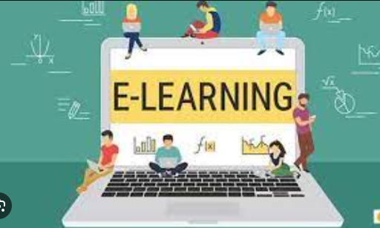

**Challenges and Consideration:**While the rise of e-learning presents numerous opportunities, it also poses certain challenges and considerations:

* **Digital Divide:** Despite the increasing accessibility of technology, the digital divide persists, with disparities in access to digital devices, internet connectivity, and digital literacy skills. Bridging this divide is essential to ensure equitable access to e-learning opportunities for all learners, regardless of their socioeconomic background or geographic location.
* **Quality Assurance:** The proliferation of e-learning platforms has raised concerns about the quality and credibility of online educational content. Ensuring quality assurance and accreditation standards is crucial to maintain the integrity and credibility of e-learning programs and credentials.
* **Learner Engagement and Motivation:** Maintaining learner engagement and motivation in online learning environments can be challenging, particularly in the absence of face-to-face interaction and social support. Designing interactive, immersive, and engaging learning experiences is essential to keep learners motivated and foster active participation.
* **Security and Privacy:** With the growing reliance on digital platforms for learning, ensuring the security and privacy of learner data is paramount. E-learning providers must implement robust cybersecurity measures and adhere to data protection regulations to safeguard learner information and maintain trust and confidence in their platform.

**Conclusion**

The rise of e-learning represents a paradigm shift in the way education is accessed, delivered, and experienced. With its unparalleled accessibility, flexibility, and personalization, e-learning has the potential to democratize access to education, empower learners, and drive inclusive economic growth and development. However, addressing challenges related to digital divide, quality assurance, learner engagement, and data security is essential to unlock the full potential of e-learning and create a future where education is truly accessible to all.